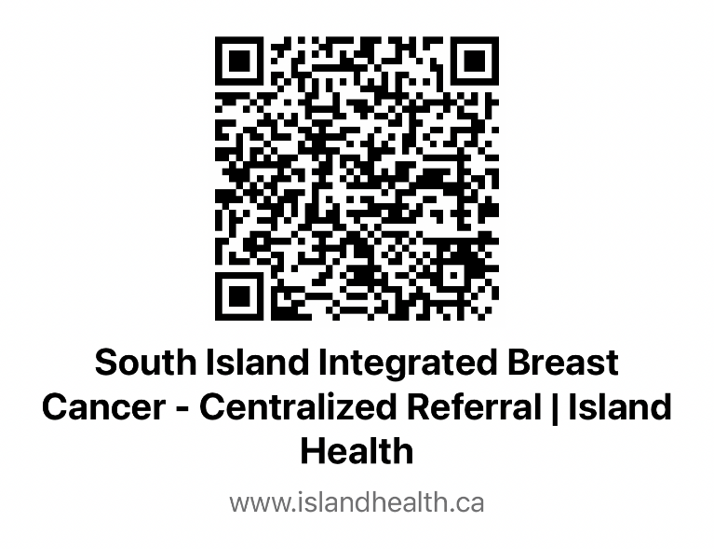
﻿ SIIBCP Referral form:

Comprehensive Guide to Breast Cancer Screening in Canada. (Also Dense breast guide)
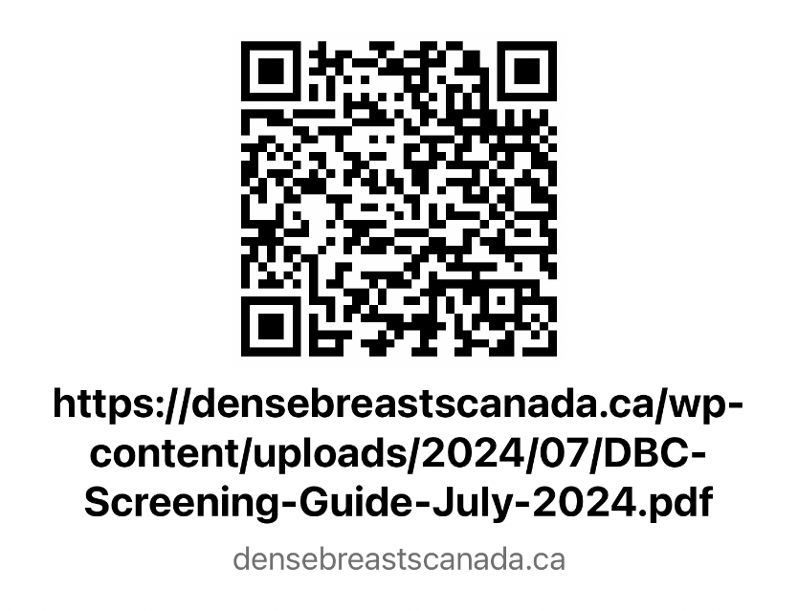

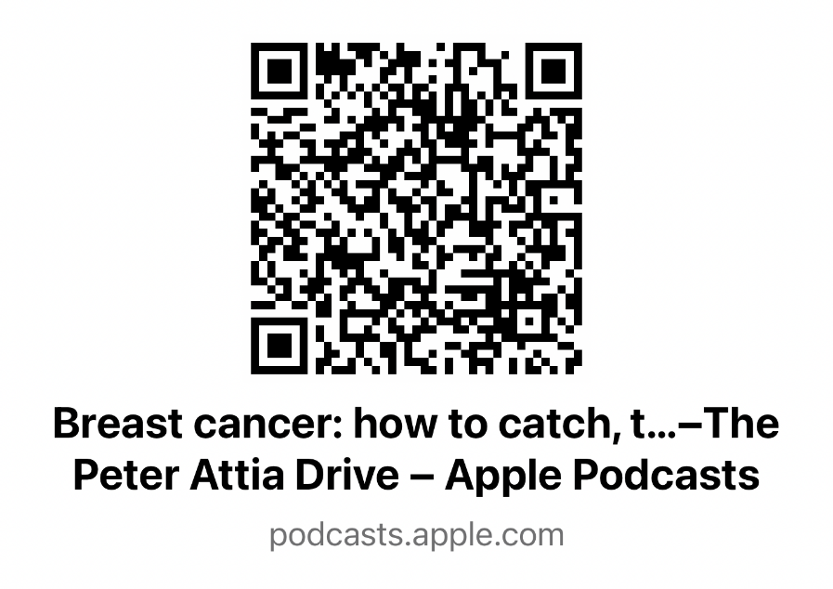
Podcast: Breast Cancer. How to Catch, Treat and Survive Breast cancer. Dr Harold Burnstein

